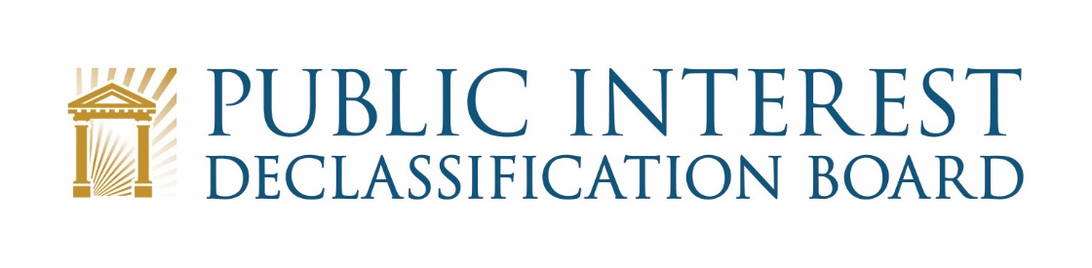

GOOGLE MEET VIDEO TELECONFERENCE

August 25, 2021
1:00 p.m. – 3:45 p.m.

Agenda

- Welcome 1:00 – 1:10 p.m.
Mark Bradley, PIDB Executive Secretary
Ezra Cohen, Chair, and all PIDB members

- National Archives Reopening Status
- Administrative matters
- Introduce Bryan Oklin as the new Acting Chief of Staff to ISOO
- Scope of meeting

- Status of Request Handling Procedures and Current Congressional Requests 1:10 – 1:50 p.m.
Ezra Cohen, PIDB Members

- Approval of Request Handling Procedures
- Status of Rep. Gallagher’s Request
- Next Steps

- Congressional Engagement and Outreach 1:50 – 2:15 p.m.
Ezra Cohen

- Seeking Avenues for Congressional Engagement
- Planning for Possible Briefings
- Next Steps

- Introduction to JFK Assassination Records Collection 2:15 – 2:30 p.m.
Robert Fahs

- Scope of the Collection
- Standards of Review for Postponement
- Presidential Certification in 2017

- Briefing on JFK Assassination Records Collection Act Agency Reviews 2:30 – 3:00 p.m. William “Jay” Bosanko, NARA Chief Operating Officer

- Discussion of Agency reviews
- Questions and Comments

- Discussion of future meetings and objectives 3:00 – 3:30 p.m.
Ezra Cohen, PIDB Members, John Powers

- October (virtual teleconference)
- November (in person meeting):
  - Potential Briefing at the National Geospatial-Intelligence Agency
  - Review of Records Requested by Sen. Murphy at ODNI
- Planning for 2022
  - Developing a monthly schedule
  - Potential Areas of Interest

- Recap and Conclusion 3:30 – 3:45 p.m.
Ezra Cohen

