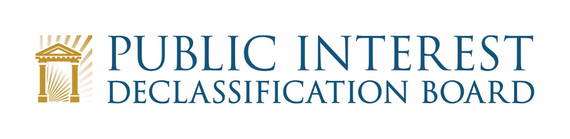

GOOGLE MEET VIDEO TELECONFERENCE:

September 23, 2021
1:00 p.m. – 2:30 p.m.

Agenda

- Welcome and Introduction of Speaker 1:00 – 1:05 p.m.
Mark Bradley, Executive Secretary

- Introduction of Mark Zaid

- Presentation by Mark Zaid 1:05 – 1:15 p.m.
Mark Zaid

- Presentation on JFK Assassination Records Collection Act Requirements
- Questions

- Welcome 1:15 – 1:20 p.m.
Mark Bradley
Ezra Cohen

- National Archives Reopening Status
- Administrative matters
- Scope of meeting

- Status of the PIDB Letter to President Biden on the JFK Records 1:20 – 1:30 p.m.
Ezra Cohen and Members

- Scope of the recommendations
- Comments and edits from PIDB members on the draft letter
- Next steps for finalizing the letter and posting it on the PIDB blog

- PIDB Blog on 9/11 Records Releases and Recommendations 1:30 – 1::45 p.m.
Ezra Cohen, PIDB Members, John Powers

- Status and current context of PIDB recommendations on 9/11 Commission Records
- Comments and edits from PIDB members on the draft blog
- Next Steps

- Discussion of future meetings and objectives 1:45 – 2:25 p.m.
Ezra Cohen and Members

- October
- November
- December
- Congressional Engagement
- Planning for 2022

- Recap and Conclusion 2:25 – 2:30 p.m.
Ezra Cohen

