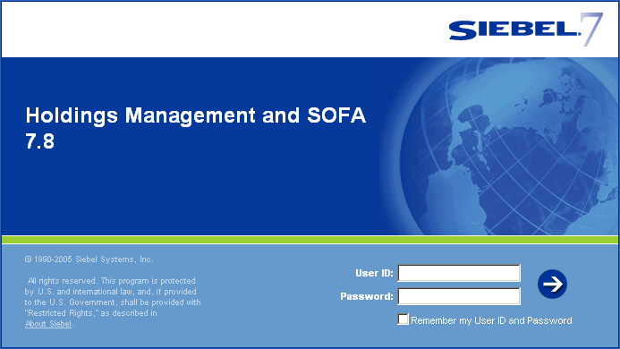

Getting Started with HMS

Training Manual

Version 2.1
July 15, 2009

Introduction
HMS Overview 3
HMS Terminology 3

Getting Started
Logging into HMS 4
Changing your HMS Password 4
Using your Web Browser Back, Forward, History, and Refresh Functions 5
Exiting HMS 5

The HMS User Interface
HMS (Siebel) Application Window Components 6

Navigation
Screen Tabs 8
Link Bars 8
View Tabs 8
The Difference Between a Screen Tab and a View Tab of the Same Name 8
Records 9
List Applets 9
Form Applets 10
Common Buttons for Lists and Forms 11

Records and Fields
Fields and Field Controls 13
Working with a Single Selection Field 14
Working with a Multi-Selection Field 14

Common Tasks
Saving Data 17
Canceling Changes 17
Using Record Hyperlinks 17
Resizing Columns 18
Organizing Columns in a List 18
Sorting Records in a List 20

Introduction to Queries
Creating, Executing, and Saving Queries 23
Query Operators 24

Introduction

HMS Overview
HMS (Holdings Management and SOFA) is an integrated technology platform designed to support the physical management of permanent, hard-copy archival records in the custody of NARA. HMS combines in a single system the archival functionality currently distributed across multiple systems (both manual and automated) throughout the agency. Overtime, HMS will subsume several existing applications used to support archival work processes (e.g., the MLR, accession databases, SpaceMan, container label programs, and other tracking databases) and integrate them in the single user interface. A key aspect of HMS is the introduction of container level control and tracking.

Eventually, HMS is expected to support most work processes for archival holdings including accessioning, processing, relocation, holdings maintenance, conservation treatment, reformatting, and risk assessment.

HMS will replace several existing applications and tools used for archival processes (see the figure below).

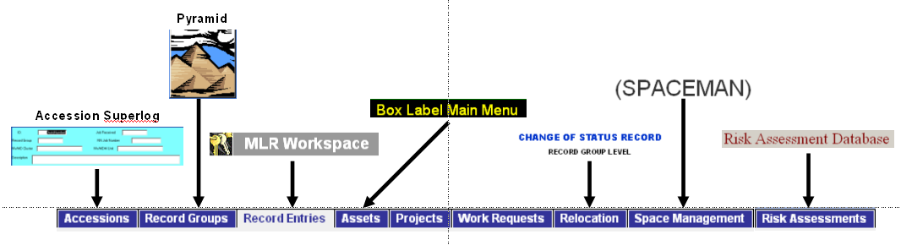
Legacy System Map

New Terminology
While terms in HMS may be new to you, what they mean is not. Some key changes are given below for your reference.

What is a Record Entry?
A record entry in HMS is equivalent to a MLR entry.

What is an Asset?
In HMS an asset will primarily refer to a container, but can also be used to designate a folder or item.

What does Availability Status mean?
Availability Status shows whether the record entry or asset can be expected to be on the shelf. If a record entry or an asset is Unavailable, then this status will give you the reason.
Getting Started

Logging into HMS

HMS Login Screen

To log in to HMS:
- Open Internet Explorer (web browser).
- Enter the web address http://gpeatest.archives.gov/hms to navigate to HMS.
- A login screen (as shown in Figure above) appears.
- Enter your User ID and Password.
- Click the arrow button.
After you login to HMS, your home page appears with a welcome message and may show additional applets (frames) depending on your business unit and role.

Changing Your HMS Password
To change your password for HMS:
- At the top of the HMS screen, click the View menu.
- Select the User Preferences option.

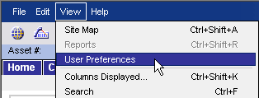

- Enter your new password in the Password field.
- Then re-enter your new password in the Verify Password field.
- Click the button.

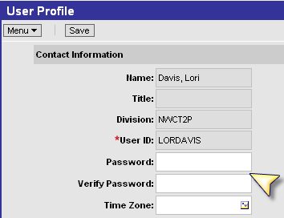

Using your Web Browser Back, Forward, History, & Refresh Functions
To navigate back and forward in the HMS application, you can click your web browser's back () and forward )buttons.
To find screens and views you recently accessed in your HMS application, your web browser's history function ().

To refresh data in HMS, it is recommended that you use Siebel query functionality. First click the button, then click the button.

Exiting HMS
Do not close the browser window (‘X’ button on top right corner) to exit the HMS application.

To exit the HMS application:
- From the application-level menu, choose File.
- Then choose Log Out.

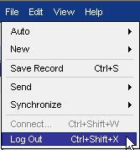

- Then close your web browser.
The HMS User Interface

The figure on the following page shows the main elements of the HMS application window.

The application-level menu is located in the upper left corner of the application window. Each menu option lets you perform a task.

The Siebel application toolbar appears below the application-level menu. The left part of the toolbar provides access to frequently used tools such as the Site Map. You use the right part of the toolbar, to find information in HMS. The tools available on the application toolbar are described in Table 1.

Application Toolbar Controls
Control | Name | Description
 | Site Map button | Displays the site map.
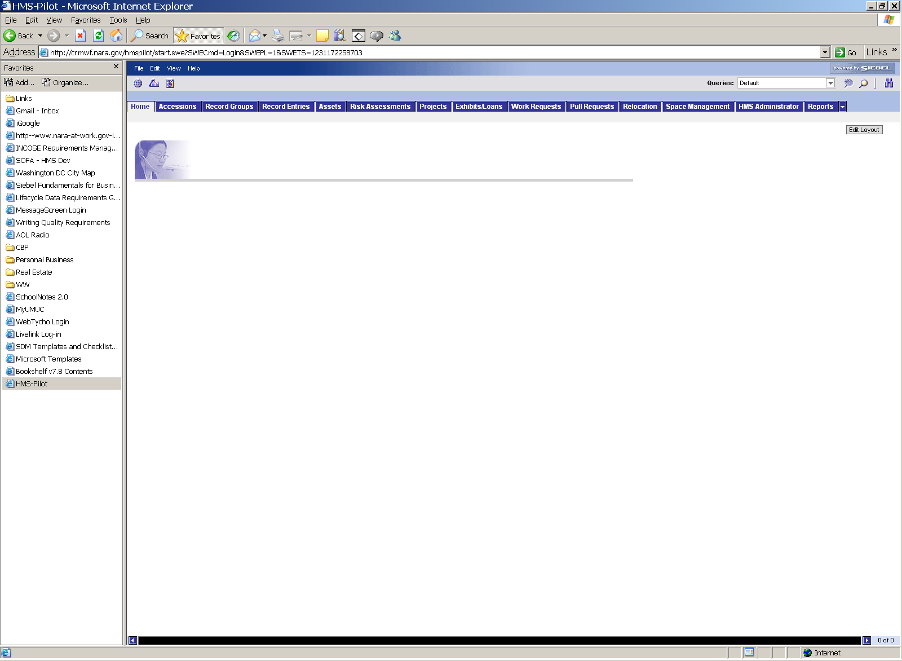 | Barcode button | Lets you upload a barcode file.
 | Reports button | Lets you access reports for the screen you are working in.
 | New query button | Launches a new query.
 | Execute query button | Executes a query after you have defined query criteria.
 | Search button | Activates the Search Center, which allows you to search and find records within HMS.

The application is organized into screens. Each screen covers a broad topic.

Views exist within screens and can contain lists, forms, and sub-views. A list consists of multiple records, presented as rows and the fields organized as columns in the list. A form shows the details for an individual record.

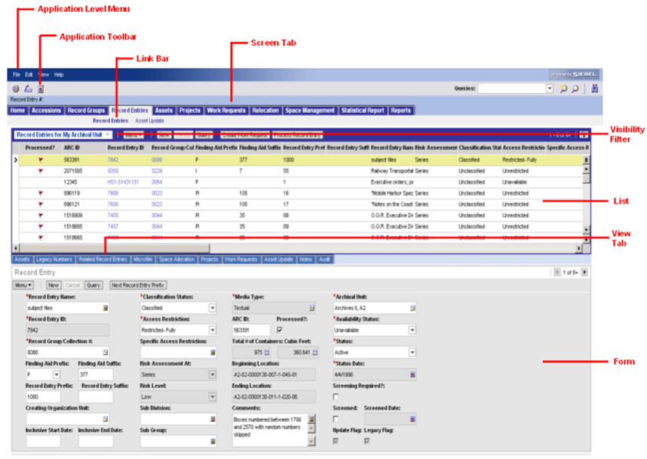
HMS Application Window Components

Navigating the HMS Interface

Screen Tabs
You access a screen by clicking the related screen tab, such as Accessions, Record Entries, or Assets, or by using the Site Map. An active screen tab appears in a different color.
You can use the visibility filter (as shown in Application Window Components figure) to access a different set of records by filtering records in a screen, based on your role within HMS.

Link Bars
Screens contain sets of information shown in views. You access views by clicking a hyperlink on the link bar. The link bar appears immediately below the screen tabs. In the link bar, the active view appears in bold text (as shown in Application Window Components figure).

View Tabs
You use view tabs to access additional information about a record after you have selected it.

In some cases, sub-views provide access to additional information about a record. Sub-views appear directly below the information displayed for a selected view tab. The sub-view gives you more details about the record selected in the view. Not all views have sub-views. If a view has a sub-view, it appears automatically. An example of a sub-view is shown below.
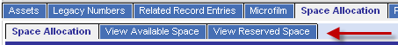
Sub-View Example

The Difference Between a Screen Tab and View Tab of the Same Name
A screen tab and view tab can have the same name (e.g., work requests). A screen tab will allow you to access all records related to certain subject. For example, the Work Requests screen will allow to see all work requests that either your unit has created and/or been assigned.

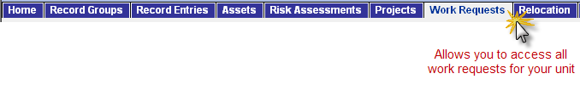The Work Requests view that is part of the Record Entries screen will allow you to see all work requests that have been created for the selected record entry.

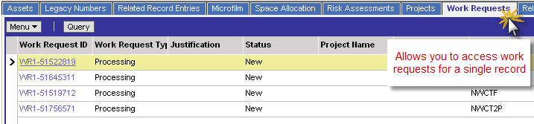

Records
A record is a collection of data organized into fields. You can select an individual record in a list by clicking any field in the record. This causes the record to be highlighted (in yellow) and adds an active record indicator (>) to the left of the record. If the field you click is editable, you can enter data in the various columns.
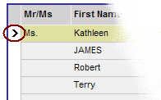
Active Record Indicator in a List Example

List Applets
After identifying the desired screen and selecting the screen tab, you must decide what set of records you want to view in the selected screen. A default set of records appears in a list below the screen tab. To navigate in a list, you use the vertical and horizontal scroll bars within the list applet.
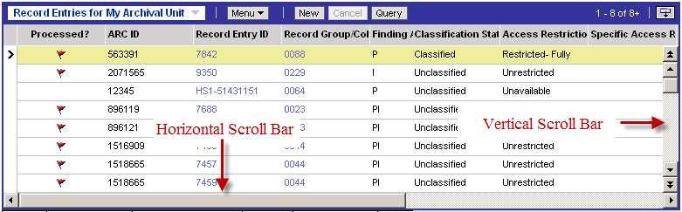
Scroll Bar Locations
Vertical scroll bars are used to navigate between records in a list. Vertical scroll bars appear to the right of lists that contain more rows than can fit on the screen. Using the vertical scroll bar you can navigate to the next record, the next record set, the previous record, or the previous record set, depending on the button you click. Table 2 describes the vertical scroll bar buttons.
Description of Vertical Scroll Bar Buttons
Control | Description
 | Go to previous record set.
 | Go to the previous record.
 | Go to the next record.
 | Go to next record set.

Horizontal scroll bars appear at the bottom of lists that contain more columns (or fields) than can fit on the screen. Use the horizontal scroll bar to move through all the columns currently being displayed.

Every list has a show more button or a show less button in the top right corner. Clicking the show more or show less button allows you to see more or fewer records.

When a list is collapsed, you can click the show more button to expand it, as shown in Figure below. When a list is expanded, you can click the show less button to collapse it, also shown in Figure below.
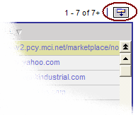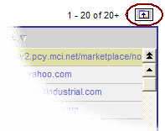
Show More Button
Show Less Button
Show More Button and Show Less Button Examples

Form Applets
When you select a record in a list (on the default view of any screen), you will see a form below that contains details for the record you selected (as shown in Figure below). A form displays the fields of a single record.

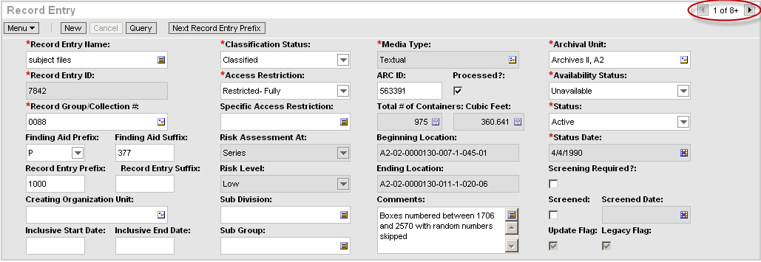
Example Form
You can use the record navigation buttons (as shown in the figure above) at the top right of each form to navigate between records in a list. When you use the record navigation buttons in a form, you are navigating to the next record or the previous record.

If you have permissions to edit the information in a form, you can make edits directly in the form.

Common Buttons for Lists and Forms
The buttons described below appear at the top of all lists and forms.

Common Buttons in Lists and Forms
Control | Description
The menu button provides access to a menu of actions that apply to the active form, list, or a selected record in a list. Using the options in the menu, you can perform actions such as copy, edit, delete, and advanced sorting.

NOTE: If you right-click in a form or a list you can access the same menu of actions provided by the menu button in that form or list.
 | Lets you create a new record. In a list, clicking this button inserts a new, empty row at the top of the list so you can create a new record. In a form, clicking this button displays a form with empty fields that you can fill in to create a new record.
 | Lets you define and launch a query in a form or list.

Individual Exercises # 1

- Identify and list the screen tabs you have in HMS.
- Navigate to the Work Requests screen. Identify and list the link bars you see below the screen tab. Also, identify the applets and their type on this screen.
- Navigate to the Work Requests screen. Identify and list the view tabs that you see.
- Navigate to the Work Requests screen. Highlight any record, and then navigate to the Selected Assets view.
(a) What is the risk level for the assets?
(b) Click the Work Requests link bar. Where does this take you?
(c) What is Created Date for this work request?
- Using HMS, how would you see a list of all work requests assigned to or initiated by your unit? Which screen tab would you begin with? Would you need to select a view tab? If so, which?
- Using HMS, how would you see a list of assets associated to a work request? Which screen tab would you begin with? Would you need to select a view tab? If so, which?
- What is the difference between the lists of work requests you found in the previous two exercises?
- On the same screen, within the form applet, where do you see the Query button? Identify the buttons to the left and right of the Query button (if any).

Take-Back Exercises:
- Navigate to the Record Entries or Work Requests screen. On the main view, how many records/rows are shown within the list applet when you click the ‘Show More’ button? Now, click on the ‘Show Less’ button. How many rows does the list now show?

Records and Fields

Fields and Field Controls
Each record consists of multiple fields. For example, an accession record may contain the following fields: accession number, record group number, or archival unit.

Fields can be editable or read-only. A read-only field displays as a grayed-out field and does not allow any editing. Click an editable field to enter or edit information in the field. Lists and forms contain field controls (see Table 4) for adding data. Required fields in a record contain a red asterisk (*), as shown in example below. Required fields must be filled in before you can save the record.

Required Field Example

HMS Field Types
Field Type | Description
Text field | A text field allows you to type text directly into the field. You can click in the field and begin typing.
Text field with pop-up | Pop-up text fields allow you to enter long texts in a pop-up window
Checkbox □ | Click the box next to a field to select or clear the check box. When you click an empty box, a check mark appears in the box. If you click a box that is selected, the check mark disappears.
Drop-down list | A drop-down list allows you to click a down arrow button to the right of a field to select from a list of available values.
Selection fields | Used when you need to select from a list of associated records or you need the capability to select multiple values from a list.

Working with a Single Selection Field
A single selection field, also known as a pick applet, will allow you to associate the selected record with another related record within HMS. For example, when working with a record entry, you may need to tie this to a record group or collection. The selection field allows you to associate the record entry to the relevant record group.

To use a single selection dialog box ():
- Click the single selection button () in the desired field. A single selection dialog box pops up in new window.

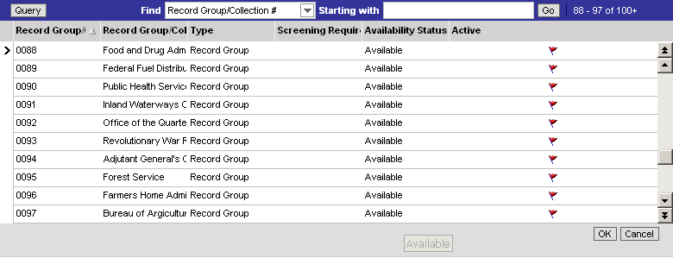

- In the dialog box, locate and select the record you want to associate. To find records in the list:
  - The scroll bars operate as described previously.
  - You can use the Find/Starting With capability. To use the Find/Starting With capability, first select the column you want to search against in the Find drop-down list. Then, enter a few characters in the Starting With field and click the button. You can select a record from the result set.
  - You also have the option of using the Query functionality (as described in a subsequent section).
- Click the button. (Note: If you do not see the OK and/or Cancel buttons within the pick applet, expand the box diagonally so that these two buttons are visible)

Working with a Multi-Selection Field
A multiple selection field will allow you to associate the selected record with multiple values or records within HMS. For example, when working with a record entry, you will need to track the media type(s) for that record entry. The selection field allows you to associate one or more media types to the record entry.

To use a multiple selection dialog box ():
- Click the multiple selection button () in the desired field. A multiple selection dialog box appears.

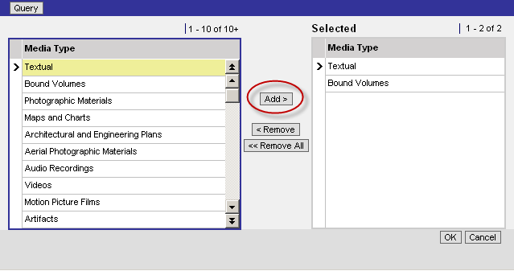

- In the dialog box the desired value(s) in the left-hand box.
- Click the button and the value(s) will be added to the ‘Selected’ box on the right.
- Click the button. (Note: If you do not see the OK and/or Cancel buttons within the multi-selection dialog box, expand the box diagonally so that these two buttons are visible)

Individual Exercises # 2

Navigate to either the Work Requests or Record Entries screen for the following exercises.

Take-Back Exercises:
- Identify the required fields on the form applet.
- Do you have permissions to edit any fields? If so, name three.
- Identify and locate an ID field (hint: Record Entry ID or Work Request ID). Why is this field read-only?
Common Tasks

Saving Data
When you are finished editing or adding a record in a form or a list, you can save your changes using several ways:
- Click the button, then select the Save Record option.
- Use the keyboard shortcut CTRL+S (on your keyboard, hold the Control key and S key simultaneously).

Canceling Changes
You may find that you need to cancel edits you have made to a record before you save it. You can undo your edits to a record only if you have not saved it yet. You can cancel edits in a form or a list in several ways:
- Click the button.
- Click the button, then select the Undo Record option.
- Use the keyboard shortcut CTRL+U (on your keyboard, hold the Control key and U key simultaneously).

Using Record Hyperlinks
A hyperlink or drill-down provides one-click access to detailed or additional information for the identified record. For example, when an ID field is displayed in a list, it is shown as a blue hyperlink. These hyperlinks allow you to go directly to more detailed information about the record.

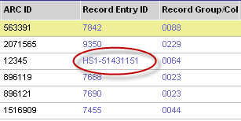

Record Hyperlinks Example

Resizing Columns
You may find that you need to alter the width of a column to view data better.

To resize columns:
- Place the cursor over the column header divider. A resize arrow appears .
- Click and drag the column divider to the right to widen the column, or to the left to narrow the column.

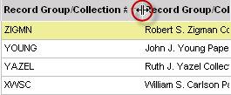

Resize Columns Example

Organizing Columns in a List
A list consists of many columns of data (or fields), some of which may not be displayed on the screen. You can add, remove, and rearrange the columns to suit your preferences by using the columns displayed feature.

To organize columns in a list
- In a list, click the button, and then select the Columns Displayed option.

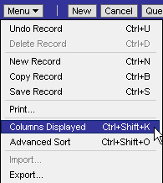

The Columns Displayed dialog box appears. If a column is in the Available Columns list, then it is currently hidden. If a column is in the Selected Columns list, then it is currently displayed in the list.
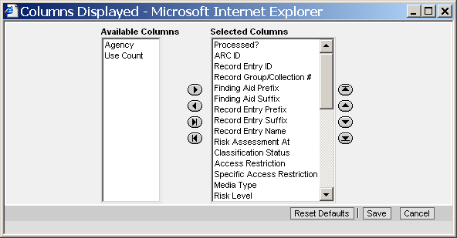
Columns Displayed Dialog Box
- Select one or more columns in one of the lists (Available Columns or Selected Columns). Hold the CTRL key to select multiple columns.
- Use the buttons between the Available Columns list and the Selected Columns list to show or hide the selected columns. The following table describes the use of each button.

Button | Description
 | Moves the identified available column(s) to the bottom of the Selected Columns list.
 | Hides identified selected columns (moved to the Available Columns list).
 | Moves all available columns to the Selected Columns list
 | Hides all columns

- Select a column in the Selected Columns list and use the column-ordering buttons to the right of the Selected Columns list to change the order in which the columns appear in the list. The following table describes the use of each button.

Button | Description
 | Moves the selected column down one position in the Selected Columns list. This moves the column to the right in the list you are modifying.
 | Moves the selected column up one position in the Selected Columns list. This moves the column to the left in the list you are modifying.
 | Moves the selected column to the bottom of the Selected Columns list, making it the right-most column in the list you are modifying.
 | Moves the selected column to the top of the Selected Columns list, making it the left-most column in the list you are modifying.

- Click the button. Any changes made to which columns are displayed and their order will become your new defaults.

Note: in the Columns Displayed dialog box allows you to reset all list columns and sizes to the original order . By clicking this button, you will lose all of your customized display of list columns for this list applet.

You can also drag and drop columns in a list applet to reorder them.

To drag and drop columns:
- Click and hold the column header.
- Drag the column header to the desired position. A red line will identify the column’s new position.
- Release the column header to fix the position. This will save these changes only for this session. To make the reorder permanent, click the button, select the Columns Displayed option, then click the button.

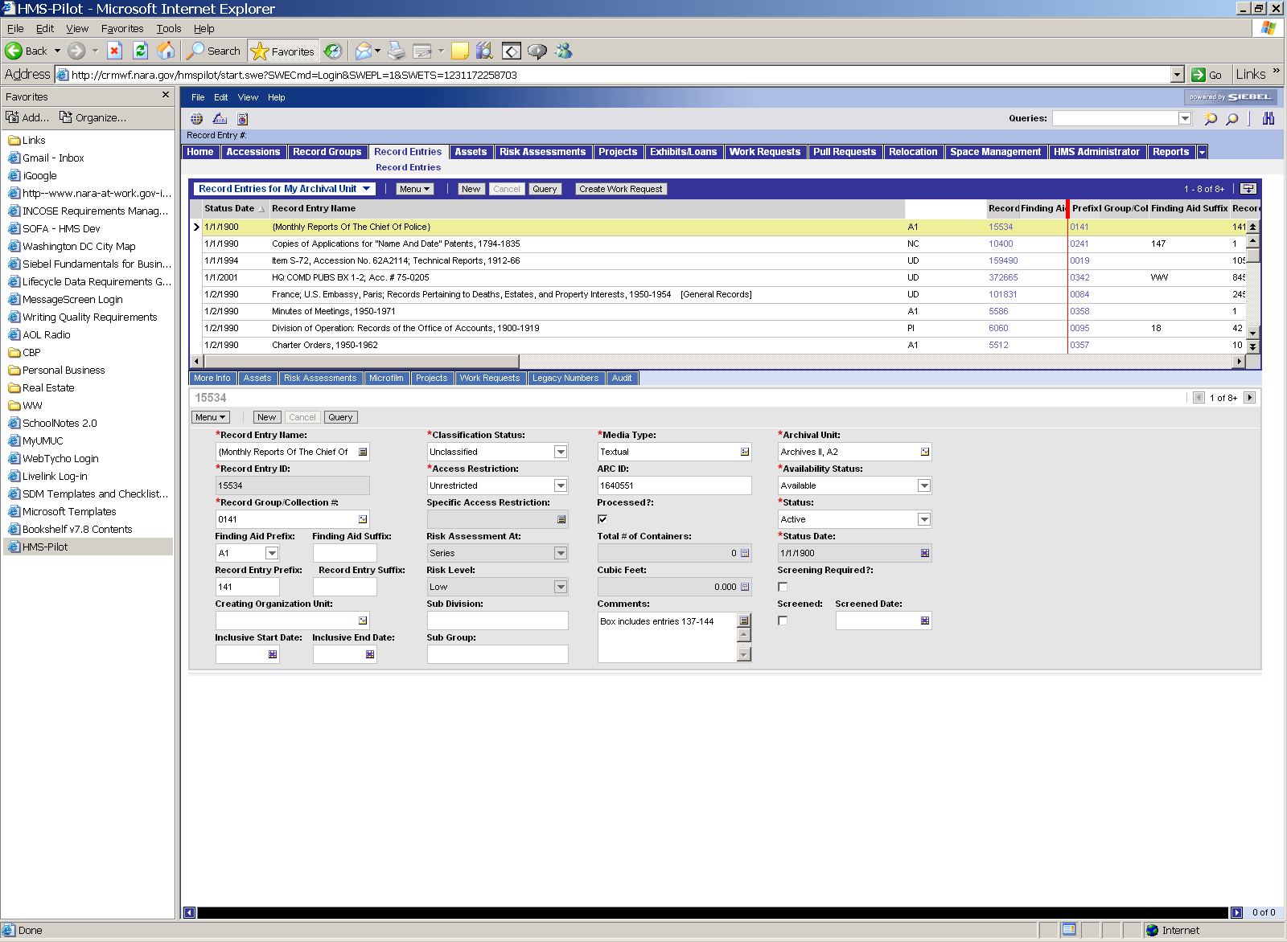

Drag & Drop Columns Example

Sorting Records in a List
You can sort the records in a column of a list in either ascending or descending order. The active sort order of a column is shown in the column header: a full triangle pointing up, means the data is sorted in ascending order on the values in the column; a hollow triangle pointing down, means the data is sorted in descending order on the values in the column.

To sort on a single column in ascending order, click the column header of the column by which you want to sort in the list. To sort on a single column in descending order, first sort on the column in ascending order by clicking the column header of the column, then click the column header again.

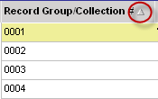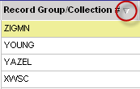

Sort Buttons

Individual Exercises # 3
- Navigate to the Work Requests screen. Change the columns displayed and column sizes as required below:

  - Hide all columns
  - Make the Work Request ID, Work Request Type, Status, Assigned Unit, Created By and Created Date columns visible
  - Move Project Name next to Work Request Type
  - Make Created By the first column in the list
  - Make Assigned Unit the last column in the list
  - Save the above changes
- Increase the size of the Project Name column.
- Undo all changes made in Exercises 1 and 2 (Hint: Reset Defaults).
- Select one of the work request records from the list that has status as ‘New’ and change the status to ‘Complete’. Save the record.
- Select another work request record by scrolling down the list and update the Comments field to ‘HMS Training Exercise for menu-undo’. Now, undo or cancel the change before saving the record.

Take-Back Exercises:
- Rearrange the columns displayed and column sizes to meet your preferences, for all of your lists within HMS (both lists on screen and view tabs) and save changes for each list.
- The next time you login to HMS, navigate to each screen tab and verify your changes to the columns displayed were saved.

Using Queries

Creating, Executing, and Saving Queries
The query feature allows you to enter specific query criteria to find records. Operators are used within a string of text or numbers you are using to locate specific records to help define the criteria. You can use one or more criteria (i.e., enter criteria in one or more fields) to conduct your query. If you use multiple criteria, your results will contain records that meet ALL criteria.

To create and run a query in a form or list:
- Click the button in the form or list.
- Enter query criteria in the blank form or list row.
- Click the button.

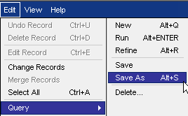
To save the query criteria for subsequent use:
- Create and run the query (as described above).
- From the application-level menu, select Edit.
- Select the Query option.
- Select the Save As option.
- In the Save As dialog box (shown below), type a name in the Query Name field.
- Click the button. The saved query now appears in the Queries drop-down list.

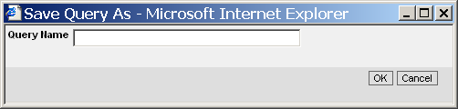
Save Query Dialog Box
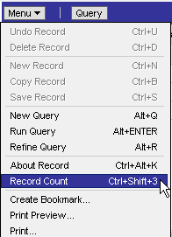
To find how many records are in your query’s results set, click the button (on list applet) and select Record Count option. The record count will popup. To close the record count pop-up, click the button.

To modify or refine an existing query, click the button on list or form applet, and select the Refine Query option. This will automatically create a new query populated with the criteria or conditions you used in you previous query. Now, you can add more criteria or modify existing criteria and execute the query again by click the button.

Query Operators
You can use simple query operators to define your query criteria.
Query Operators
Query Operator | Purpose | Example
* | Wildcard. Placed anywhere in a string, returns records containing the string or containing the string plus any additional characters at the position at which the asterisk appears, including a space. | Car* finds Car, Carson, and Carbon
OR, or | Placed between values, returns records for which at least one condition is true. | Army or Navy will return all records that have either the word army or the word navy in the query field

Individual Exercises # 4
- Query for all work requests that are for processing (Work Request Type = Processing). Once you get the results, get the record count.

- Now, refine this query to find only work requests for processing that have ‘New’ status and get the record count.
- Again, refine this query to find only work requests for Record Group 1 and get the record count.
- Navigate to the Work Requests screen. Select a work request that is for preservation. Drill down on either the Record Group/Collection # or Risk Assessment ID (depending upon which you have access to). Where does this take you?
- (a) If you have the Record Entries screen, find one of record entry having one of the following Record Entry IDs – 7218, 7220, 7222, 7224, or 7226. Then, see all work requests associated to the record entry. Drill down on one Work Request ID. Where does this take you?
Or
(b) If you the Risk Assessments screen, find one risk assessment with a Risk Assessment ID ending in 4602, 3134, 4739, 4608, or 1721. Then, see all work requests associated to the risk assessment. Drill down on one Work Request ID. Where does this take you?

Take-Back Exercises:
- Query for all Record Entries that have the term ‘vietnam’ in the Record Entry Name. (Hint: user wild card *)
- Refine the above query to narrow the list to get Record Entries for Record Group 0059. How many entries do you see now?

