Stakeholder Requirements Specification   
(StRS)

*Template*

<Project Name>

**Version X.0 <DRAFT | FINAL>**

**Prepared by <author>**

**<Date created (Month XX, Year)>**

**Table of Contents**

**1** **Introduction 4**

1.1 Purpose 4

1.2 Scope 4

1.2.1 Assumptions 4

1.3 References 4

1.3.1 Compliance 5

1.3.2 Guidance 5

**2** **Business Abstract 6**

2.1 Business Purpose 6

2.2 Business Scope 6

2.3 Stakeholders 6

**3** **System Abstract 7**

3.1 System Purpose 7

3.2 System Scope 7

3.3 System Overview 7

3.3.1 System Context 7

3.3.2 System Functions 7

3.3.3 User Roles and Characteristics 7

**4** **Stakeholder Requirements 9**

4.1 Attributes 9

4.1.1 Types 9

4.1.2 Categories 9

4.2 Requirements 10

**Appendix A – Glossary 13**

**Revision History**

|  |  |  |  |
| --- | --- | --- | --- |
| **Date** | **Version** | **Author** | **Revision Description** |
| <mm/dd/yyyy> | <x.x> | <FirstName> <LastName> | <TBD> |
|  |  |  |  |
|  |  |  |  |

# Introduction

This section introduces the Stakeholder Requirements Specification (StRS) for <Project Name>. It discusses the purpose, scope and content of the document and provides an overview of the functionality that is addressed by the requirements.

## Purpose

<Provide a very brief description of the purpose of the project and what the StRS does to support this goal.>

<This section may simply say something like "The purpose of this document is to provide the stakeholder requirements for <Project Name> along with a context to help the reader understand them."

More information may be required. For example, if the point of the project is to do a study and make recommendations, this section should include a brief description of the study and a statement like "The purpose of this document is to present the stakeholder requirements derived from the recommendations of the study.">

## Scope

<Provide a description of the scope of the document.>

<This section may be a simple statement like "The document addresses the full scope of the <Project Name> project." However, for something like a modification to an existing system, the scope of the document (and the requirements) may only be the new requirements or a portion of the existing system, in which case this section should make clear what is in and what is out.>

### Assumptions

<It is important to document the assumptions that underlay the document and / or stakeholder requirements. If there are none, just state "None".>

The following assumptions pertain to the contents of this document in general and to the requirements specifically:

* <TBD1>
* <TBD2>
* <TBD3>

## References

This section lists the sources that were utilized during the refinement of the <Project Name> stakeholder requirements. It consists of two sub-sections, “Compliance” and “Guidance”. The documents listed under “Compliance” directly influenced the content of the stakeholder requirements (i.e., they contain requirements); the documents listed under “Guidance” contain information pertinent to the stakeholder requirements but do not themselves contain requirements.

### Compliance

1. <Project Business Case>
2. <Project Vision>
3. <Project ConOps>
4. <Project Business Process Analyses (BPAs)>
5. <Project Interview Records>
6. <Project Survey Results>
7. <Feature Vision documents>
8. *Section 508 of the Rehabilitation Act of 1973, as amended (29 U.S.C. §794 (d));* US Government; 1/03/2012; <http://www.section508.gov/>.
9. *Information and Communication Technology (ICT) Standards and Guidelines (82 FR 5790);* US Government; 1/18/2017; <https://www.gpo.gov/fdsys/granule/FR-2017-01-18/2017-00395>.
10. <TBD>

### Guidance

1. *NARA Systems Development Life Cycle (SDLC) Methodology Version 1.6*; NARA; 11/27/2013.
2. *NARA Enterprise Requirements Program Management Plan Version 3.1*; NARA (IR); 04/26/2019.
3. *NARA Requirements Verification Traceability Matrix (RVTM) Template Version 2.4*; NARA (IR); 02/25/2019.
4. *International Standard ISO/IEC/IEEE 29148:2011(E): Systems and software engineering —Life cycle processes — Requirements engineering*; Institute of Electrical and Electronics Engineers, Inc. (IEEE); 12/1/2011.
5. <Project SDLC Tailoring Plan>
6. <Stakeholder Analysis>
7. <TBD>

# Business Abstract

This section introduces the <Project Name> project and describes its business context.

## Business Purpose

<Describe at the organization level the reason and background for which the organization is pursuing new business or changing the current business in order to fit a new management environment. In this context it should describe how the proposed system will contribute to meeting business objectives. Note: Information for this section can be copied from a Business Needs Analysis document, Business Case or ConOps.>

## Business Scope

<Provide a short description of the system being specified including name, high level benefits, objectives, and goals. Explain what the system will do to satisfy the business need. Note: If a separate vision and concept of operations document is available, please summarize the content here.>

## Stakeholders

The Stakeholders that are relevant to the <Project Name> requirements are specified in Table 2-1.

<List the groups or classes of stakeholders and describe how they will influence the organization and business, or will be related to the development and operation of the system. This table may be modified appropriately. Table 2-1 is required.>

<The "Symbol" column of 1 is for the organization symbol when a NARA organization or the abbreviation / acronym for an external organization.>

**Table 2-1: Stakeholders – Organizations**

|  |  |  |  |
| --- | --- | --- | --- |
| **Organization** | **Type** | **Main Interests** | **Impact of Project** |
| <The organization's full name and organizational symbol or abbreviation/acronym for an external organization.> | <Primary | Secondary> | <The main interests of the organization as regards the project.> | <The impact of the outcome of the project on the organization.> |
|  |  |  |  |
|  |  |  |  |

# System Abstract

This section introduces the <Project Name> project and describes its system context.

## System Purpose

<Define the reason(s) for which the system is being developed or modified.>

## System Scope

<Define the scope of the system under consideration by

a) Identifying the system to be produced by name.

b) Referring to and stating the results of the earlier finalized needs analysis, in the form of a brief but clear expression of the user's problem(s). It explains what the system will and will not do to satisfy those needs.

c) Describing the application of the system being specified. As a portion of this, it should describe all relevant top level benefits, objectives, and goals as precisely as possible.>

## System Overview

### System Context

<Describe at a general level the major elements of the system, to include human elements, and how they interact. The system overview includes appropriate diagrams and narrative to provide the context of the system, defining all significant interfaces crossing the system's boundaries.>

### System Functions

<Provide a summary of the major functions (i.e., fundamental actions / system capabilities) that the system will perform. The summary should show the different functions and their relationships and should be organized in a way that makes the list of functions understandable to the stakeholders. This summary typically consists of a simple hierarchical decomposition of the functions, but is dependent upon the specific system.>

<The functions are typically identified via the requirements elicitation activity. Although functional analysis and decomposition is typically a system engineering activity that is associated with system architecture and design, some of the techniques involved may be useful to the BA; there are many information resources available via the Internet.>

<When a Concept Of Operations (ConOps) exists, it may include a Functional Decomposition that can be used as a basis for this summary; if the Functional Decomposition is very detailed, you may want to reduce the amount of detail for inclusion in this document.>

### User Roles and Characteristics

The business user roles that are relevant to the <Project Name> requirements are specified in Table 3-1.

<Identify each type of user/operator/maintainer of the system (by function, location, type of device), the number in each group, and the nature of their use of the system.>

**Table 3-1: User Roles and Characteristics**

|  |  |
| --- | --- |
| **Role** | **Characteristics** |
| <Role1 Name> | <Responsibilities and system usage> |
| <Role2 Name> | <Responsibilities and system usage> |
| <Role3 Name> | <Responsibilities and system usage> |
|  |  |

# Stakeholder Requirements

This section describes how the <Project Name> stakeholder requirements are organized and provides access to the stakeholder requirements via an embedded Microsoft® Excel® object.

## Attributes

This section describes the attributes of the stakeholder requirements utilized for <Project Name>.

### Types

Three types of requirements are identified for <Project Name>, as specified in Table 4-1.

**Table 4-1: Types of Requirements**

|  |  |
| --- | --- |
| **Category** | **Description** |
| Business | Business requirements define the critical activities that a project that must perform to meet the organization's objective(s) while remaining solution independent (i.e., "what the organization wants or needs to be able to do once the project is completed").  Business requirements are included with the stakeholder requirements to provide traceability and to promote a better understanding of the stakeholder requirements by making the associated business requirements more accessible. The business requirements typically come from the project's business case.  Note: It may not be appropriate to include the business requirements with the stakeholder requirements because of various issues, such as availability. However, it is highly recommended that they be included when possible. |
| Business Rule | Criteria or condition that dictates a system’s action or response. |
| Stakeholder | Stakeholder requirements define decisions about business needs, goals, and objectives from the perspective of the stakeholders and their role in the business.  Stakeholder requirements are expected to decompose the business requirements. |

### Categories

Four categories of requirements are identified for <Project Name>, as specified in Table 4-2.

**Table 4-2: Categories of Requirements**

|  |  |
| --- | --- |
| **Category** | **Description** |
| Constraint | Constraints limit the options open to a designer of a solution by imposing immovable boundaries and limits (e.g., the system shall incorporate a legacy system element, or certain data shall be maintained in an online repository). |
| Functional | Functional requirements describe the system functions or tasks to be performed. |
| Non-Functional | Non-functional requirements identify operational or system properties. They define how a system should be. Information Management, Availability, Backup and Recovery, Compatibility, Maintainability, Reliability, Transferability, Performance, Capacity, Scalability, Security, Usability, and User Interface requirements are examples of this type. |
| N/A | Used for Business requirements for purposes of completeness, i.e., to ensure that every requirement traces to a category. (Business requirements are not typically categorized.) |

## Requirements

The <Project Name> stakeholder requirements are maintained in Requirements Verification Traceability Matrix (RVTM) that is embedded in this document. To view the contents of this Microsoft® Excel® workbook, double-click the following icon.

<This embedded object (template) below should be replaced by the project's stakeholder requirements workbook.>

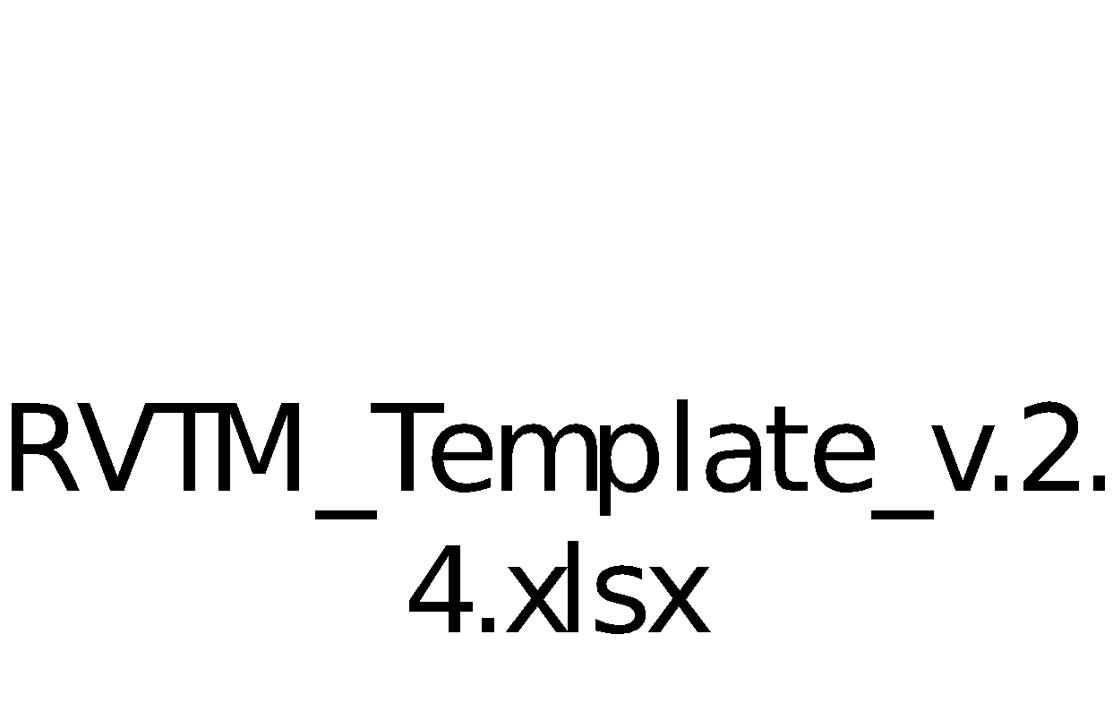

*↑ double-click to open ↑*

Note: You must have Microsoft Excel 2007 or newer to view the above workbook.

The equivalent “viewing” application may also be used.

This RVTM workbook consists of two worksheets:

* Requirements

This worksheet contains the stakeholder requirement id (i.e., Req #), requirements text, and related information.

The contents of this worksheet are sorted in ascending order by “Req #”.

Columns with a red header are required attributes. Columns with a blue header are optional attributes.

* Standard Values

This worksheet contains the lists of standard values that are used by the Requirements Management Division (IR) to instantiate drop-down lists for some of the columns of the Requirements worksheet.

The columns in the Requirements worksheet are defined as follows:

* Req #

A unique identifier for the requirement.

* Requirement Text

The text of the requirement.

* Type

The type of the requirement, such as "Business" or "Stakeholder". Refer to Table 3-1.

* Category

The category of the requirement, such as "Functional" or "Non-Functional". Refer to Table 3-2.

* Feature

The high-level function, capability, feature or other grouping that has meaning for the stakeholders.

* Req Priority

The priority of the stakeholder requirement as assigned by the stakeholders.

The valid values for this column (MoSCoW) are recorded in Section 6 of Reference 1.3.2-2 and are reproduced below:

Must[1] requirements that are CRITICAL to meeting the project's objectives

Should requirements that are critical and should be included if possible, but which can be excluded

Could requirements that are part of the project's scope and add or enhance project benefits

Would requirements that do not have a significant impact on project benefits or could be considered as a “would like to have”

* Status

The status of the requirement.

* Target Release

The release in which the requirement will be developed. Note that this column may be blank and hidden from view upon the initial documentation of the requirements, but should be updated during the appropriate phase of the project.

* Source

The source of the stakeholder requirement, such as "Business Case" or "Interview".

* Process Description

The process description(s) or diagram(s) that are applicable to the stakeholder requirement.

* Use Case

The use case(s) that are applicable to the stakeholder requirement.

* Notes

Pertinent additional information about the requirement.

For example, it is sometimes very difficult to state a function clearly and precisely. In this case, simpler and more easily understood requirement text might be used with additional information under “Notes” which expands upon the intent of the requirement.

Note: There are additional columns in the embedded RVTM to capture the requirements traceability to Design, Development, Verification, and Deployment Preparation (User Acceptance Testing) attributes. These columns will be blank upon the initial documentation of the requirements, but should be updated during the appropriate life cycle phases of the project.

# Appendix A – Glossary

<Define all of the abbreviations (including acronyms) and terms necessary to properly interpret this StRS.>

|  |  |
| --- | --- |
| **Abbreviation** | **Definition** |
| ConOps | Concept of Operations |
| e.g. | exempli gratia ('for the sake of example') |
| i.e. | id est ('that is'; 'in other words'; 'that is to say') |
| IEC | International Electrotechnical Commission |
| IEEE | Institute of Electrical and Electronics Engineers, Inc. |
| Inc. | Incorporated |
| IG | [NARA organization] Program Management Division, Information Services |
| IJ | [NARA organization] IT Project Management Division, Information Services |
| IR | [NARA organization] Requirements Management Division, Information Services |
| ISO | International Organization for Standardization |
| IT | Information Technology |
| MoSCoW | Must, Should, Could, Would (requirements priorities, in order of decreasing importance or desirability) |
| N/A | Not Applicable |
| NARA | National Archives and Records Administration |
| PM | Project Manager |
| POC | Point Of Contact |
| REQ | Requirement |
| RVTM | Requirements Verification Traceability Matrix |
| SDLC | Systems Development Life Cycle |
| StRS | Stakeholder Requirements Specification |
| TBD | To Be Determined |

|  |  |
| --- | --- |
| **Term** | **Definition** |
| Stakeholder | An individual, group, or organization who may affect, be affected by, or perceive itself to be affected by a decision, activity, or outcome of a project. |

<Delete the word *Template* from the title page and the footer. Do not forget to remove the watermark! To remove the watermark in the entire document using Microsoft® Word®, select the entire document (Ctrl-A) then do Ribbon > Design > Page Background > Watermark from Page Background group > *Remove Watermark*.>

1. Minimal Useable SubseT (MUST)