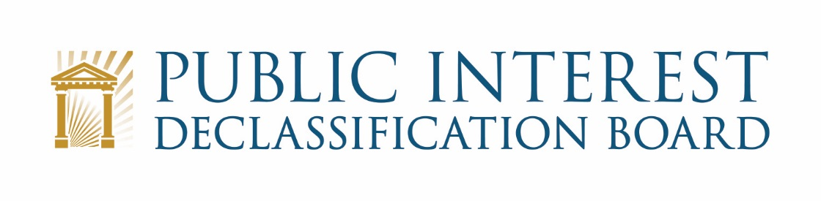
GOOGLE MEET VIDEO TELECONFERENCE:

February 18, 2021
1:00 p.m. – 2:30 p.m.

Agenda

- Welcome 1:00 – 1:05 p.m.
Mark Bradley, PIDB Executive Secretary

- Member Discussion –Strategic and Practical Planning 1:05 – 2:00 p.m.
Ezra Cohen, Chair, and all PIDB members

- Scope of the PIDB’s purpose
  - Authorizing legislation
- Potential topical areas of interest
  - 9/11 Commission
  - Iran/Contra Special Prosecution Force
  - Five most requested FOIA Requests at National Security Agencies
  - Specific Congressional Requests for PIDB Review
- Potential policy areas of interest
  - Over-classification: SAPs; Space; Congressional perspectives
  - Technology Investment in Classification and Declassification
- Potential process areas of interest
  - Transfer of NSC Records to NARA and potential for AI/Machine Learning
- Discussion

- Discussion of Letter to the President 2:00 – 2:05 p.m.
John Powers, Associate Director for Classification Management

- Discussion
- Timing for delivery

- Discussion of Senator Murphy’s Request 2:05 – 2:15 p.m.
John Powers
Ezra Cohen

- Update

- Administrative and Logistical Information 2:15 – 2:25 p.m.
Mark Bradley, John Powers, and Michelle Boyd

- NARA COVID Policies and its effect on the PIDB
- Discussion of frequency, length and preferences for virtual meetings
  - Executive Sessions
  - Potential Public Meetings

- Administrative Updates 2:25 – 2:30 p.m.
Michelle Boyd, ISOO Chief of Staff

- Security clearances update
- Other administrative matters

- Conclusion 2:30 p.m.
Ezra Cohen
Mark Bradley

