June 10, 2016

To our Valued Customers:

Effective October 1, 2016, the Federal Records Centers Program will begin charging an additional fee for certain transactions that are not submitted through the ARCIS Customer Portal, specifically records transfers (service code A0) and reference requests (service codes R1, R2, R3, R4, RW, RX). This additional fee will not apply to civilian and military reference requests for Official Military Personnel Folders (OMPFs), Official Personnel Folders (OPFs), and Employee Medical Folders (EMFs).

In August 2011, the Federal Records Centers Program (FRCP) released the Archives and Records Centers Information System (ARCIS) Customer Portal version 2.0 which enables agencies to:

- submit Reference Requests,
- submit Records Transfers,
- apply increased levels of access controls to records, and
- manage user administration to gain better control over who has access to agency records.

In addition to these benefits, initiating online reference requests and records transfers is in step with the Managing Government Records Directive issued on August 24, 2012 that requires to the fullest extent possible, agencies eliminate paper and use electronic recordkeeping.

If your agency has not deployed on the ARCIS Customer Portal v2.0, please provide the names and email addresses for no more than two Super Administrators to your Account Manager, [Insert Account Manager Name], at account.mager@nara.gov. A Super Administrator has the capability and authority to decide how the agency is configured in ARCIS and is assigned all the capabilities the system has to offer to include creating, modifying, and activating/inactivating user profiles.

To assist you in this transition, we have arranged a nine minute video to introduce you to ARCIS as well as short training videos that show you how to use each of the separate functions.

Once deployed, your agency will assume full responsibility for user administration and the ARCIS Help Desk will no longer manage your agency’s user profiles. The Help Desk is still available to answer your questions.

Sincerely,

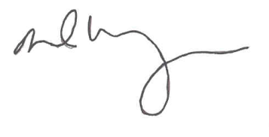
DAVID M. WEINBERG
Director
Federal Records Centers Program

