June 13, 2016

To our valued customers:

We appreciate you choosing the NARA Federal Records Program for your storage and service needs. We are dedicated to providing valuable and exceptional service. After several requests, we are pleased to inform you that we will offer Reserved Space Storage in the Federal Records Centers.

Effective October 3, 2016, the FRC will offer Reserved Space Storage at all of our facilities with the exception of Denver and Washington National Records Center. If you choose to take advantage of this service, it will appear on your invoice as Storage Code SR. The fee for this service will be the same as your S1 (Standard Service).

We are aware of the challenges facing Federal agencies and we are committed to providing the quality records management services you depend on in the most cost-effective way possible. This new service will provide your agency with benefits of cost control, carefree maintenance, climate control and security.

If you have a strategic need for this service, please contact your Account Manager, [Insert Account Manager Name], at account.mager@nara.gov.

We appreciate your continued support of NARA’s Federal Records Centers Program, and we look forward to continuing our relationship as we build on our shared commitment to Federal records management.

Sincerely,

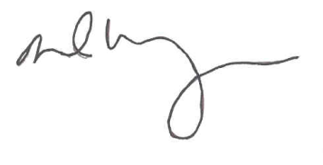
DAVID M. WEINBERG
Director
Federal Records Centers Program

