February, 2016

To our valued customers :

In 2015, the Federal Records Centers Program implemented a new comprehensive verification process for individuals who request and/or pick up records held in the custody of the Washington National Records Center (WNRC). This gave us the opportunity to ensure that your records are accessed only with the express permission of the owning agency. WNRC stores almost 4 million cubic feet of federal records and services over 100,000 reference requests annually. We want to take every measure to ensure your records are safely maintained.

Last year, you provided us with a list of individuals who were authorized to request records, pick up records or both. If this authorization was done by giving individuals the capability of Reference Request – Create while using the newer version of the ARCIS Customer Portal (User Administration, Access Controls, Records Transfers, Reference Requests) with user access controls activated, then no action needs to be taken. The user’s authorization will remain valid until your ARCIS administrator removes the user’s Reference Request – Create capability or inactivates the user’s account.

Any authorized users that were submitted via ARES Authorization Form prior to January 1, 2016 will have their authorizations expire on June 30, 2016. If you wish to extend their authorization or add additional users, please review and update the current listing.

To facilitate this process, we have enclosed the listing of the current authorized individuals whose authorizations will expire June 30th. You have the option to update the attached list and return with a statement of approval or submit a new ARES Form with your signature, which is also attached. Send all documentations to Karen A. Scott, via email at karen.scott@nara.gov.

Sincerely,
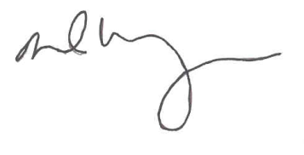
DAVID M. WEINBERG
Director, Federal Records Centers Program

