January 23, 2017

To Our Valued Customer:

As a reminder effective February 1, 2017, the Federal Records Centers Program will assess a surcharge for non-portal transactions that are not submitted through the ARCIS Customer Portal, specifically records transfers (service code AY) and reference requests (service codes RY). This additional fee will not apply to civilian and military reference requests for Official Military Personnel Folders (OMPFs), Official Personnel Folders (OPFs), and Employee Medical Folders (EMFs).

If your agency has not deployed on the ARCIS Customer Portal v2.0, please provide the names and email addresses for no more than two Super Administrators to your Account Manager. A Super Administrator has the capability and authority to decide how the agency is configured in ARCIS and is assigned all the capabilities the system has to offer to include creating, modifying, and activating/inactivating user profiles.

To assist you in this transition, we have arranged a nine minute video to introduce you to ARCIS as well as short training videos that show you how to use each of the separate functions.

Once deployed, your agency will assume full responsibility for user administration and the ARCIS Help Desk will no longer manage your agency’s user profiles. The Help Desk is still available to answer your questions.

Sincerely,

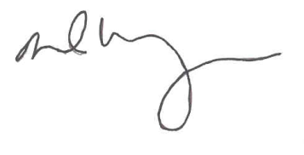
DAVID M. WEINBERG
Director
Federal Records Centers Program

