June 15, 2017

To Our Valued Customers:

On January 6, 2017, we sent a letter in regards to improving disposal procedures through a new Communications and Disposal Module (CM/DM) in ARCIS. The letter stated that once the current pilot phase is completed, the FRCP anticipated that agencies would begin enrolling in the CM/DM disposal process by July 1. Based on customer feedback during the pilot phase we have decided to postpone the enrollment phase to make modifications and will notify you when we are prepared to implement.

We apologize for any inconvenience. Our goal is to provide our agencies with the best customer service. We appreciate your continued support of NARA’s Federal Records Centers Program, and we look forward to continuing our relationship as we build on our shared commitment to Federal records management.

Sincerely,

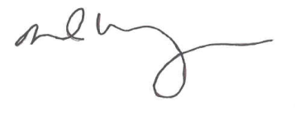

DAVID M. WEINBERG

Director, Federal Records Centers Program

