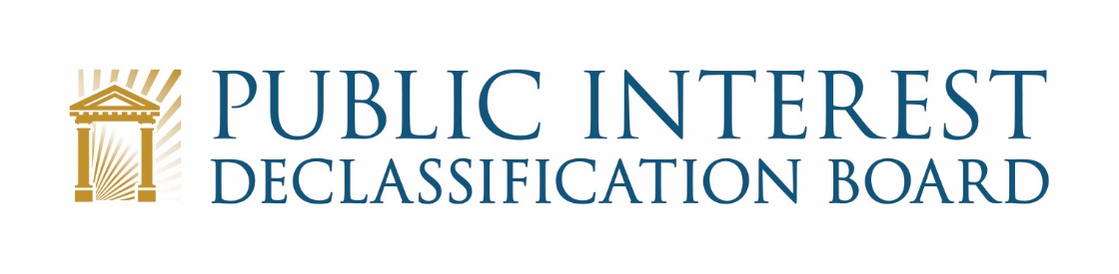

GOOGLE MEET VIDEO TELECONFERENCE:

October 26, 2021
9:00 – 10:15 a.m.

Agenda

- Welcome 9:00 – 9:05 a.m.
Mark Bradley, Executive Secretary
Bryan Oklin, ISOO Chief of Staff
Ezra Cohen, Chair

- Welcome to Sharmila Bhatia
- National Archives Reopening Status
- COVID-19 Vaccine Requirements
- Scope of meeting

- Preparations for Meetings NGA and ODNI, Nov. 3-4 9:05 – 9:20 a.m.
John Powers and Beth Fidler

- NGA – November 3
- ODNI – November 4

- Providing Recommendations on Revising Executive Order 13526 9:20 – 9:30 a.m.
Mark Bradley and Bryan Oklin

- Discussion
- Possible Recommendation and Next Steps

- Status of Congressional Engagement Activities 9:30 – 9:45 a.m.
Ezra Cohen and John Tierney

- Recap of Teleconferences with Rep. Quigley and Rep. Womack
- Discussion and Possible Next Steps

- Potential PIDB Annual Report to Congress 9:45 – 9:55 a.m.
John Powers

- Scope and Timeframe for Delivery to Congress

- Discussion of future meetings and objectives 9:55 – 10:10 a.m.
Mark Bradley, Ezra Cohen and PIDB Members

- Possible meeting(s) in December 2021
- Planning Executive Session Meetings in 2022
- Possible Public meetings

- Recap and Conclusion 10:10 – 10:15 a.m.
Ezra Cohen

