Electronic Records Management Use Cases Overview

April 30, 2020
Version: 1.0

INTRODUCTION
The National Archives and Records Administration’s Office of the Chief Records Officer is the OMB-designated Standards Lead for Electronic Records Management (ERM). This work is part of the Federal Electronic Records Modernization Initiative (FERMI), NARA’s effort to develop a comprehensive government-wide strategy for procuring records management solutions and services. FERMI has two primary goals:

- To help agencies obtain Electronic Records Management (ERM) solutions and services that fit their needs through an improved procurement process; and
- To proactively address changing trends in ERM by setting policy for new solutions and services.

NARA created Universal Electronic Records Management Requirements to assist agencies in achieving these goals. These requirements identify high-level program and system needs for agencies to follow. NARA also partnered with the General Services Administration (GSA) to update the procurement vehicle related to physical records management (SIN 51 504) and to create a new one for electronic records management (518210ERM). GSA in is the process of creating Consolidated Schedules. Additionally, NARA is coordinating with GSA’s Office of Shared Solutions and Performance Improvement (OSSPI) to serve as the Standards Lead for Electronic Records Management on the Business Standards Council (BSC).

Agencies can use the FERMI resources to comply with the policies and mandates set forth by NARA and the Office of Management and Budget (OMB). These resources will help agencies gain greater consistency, reliability, and efficiency in managing their electronic records.

PURPOSE
With the assistance of the FERMI Requirements Working Group, NARA is developing the components of an Electronic Records Management Federal Integrated Business Framework (ERM-FIBF) based on the standards set out in the OSSPI’s Federal Integrated Business Framework (FIBF). The FIBF (see Figure 1.) serves as a model to help the Federal government better coordinate and document common business needs, improve processes and performance, and drive economies of scale. With the development of the ERM-FIBF, NARA hopes to ensure records management requirements conform to the FIBF and are addressed in all Federal Service Areas.

Electronic Records Management is a standards area. Other areas include Financial Management, Human Resource Management, Grants Management, Procurement, and Travel Management. Within the larger FIBF context, the Electronic Records Management mission support function is a bit different. Records management requirements should be embedded within all the other end-to-end processes that create records in other Service Areas. For example, capturing records in the payroll process and ensuring proper disposition according to NARA’s General Records Schedule (GRS). NARA is working with the other Standards Leads to ensure the enabling functions of ERM are incorporated into all other relevant mission support functions.

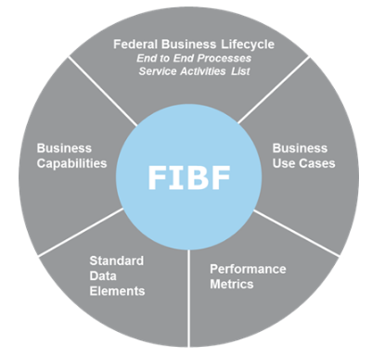
Figure 1. Federal Integrated Business Framework diagram

NARA has developed a library of Use Cases for Electronic Records which reflect the business needs, or requirements an agency must follow to meet records management requirements. The Use Cases provide example ERM workflows for agencies, shared services providers, and vendors. By mapping these core business capabilities in workflows, agencies have a tool to ask vendors how they meet the required capabilities. They can use the workflows as a comparison tool when asking different vendors and service providers to perform the same workflow to show how they accomplish the goal of managing electronic records. This can be especially helpful if the solutions and services were not designed specifically for a records management purpose.

Once vendors self-certify their solutions and services meet NARA’s Universal ERM Requirements, GSA can list them as available for procurement. The Use Cases form the foundation for a comprehensive Federal ERM procurement strategy by modeling the functionality agencies need performed by records management solutions and services.

Potential ERM Solutions and Services
FERMI is centered on improving agencies’ ability to procure and implement ERM solutions and services. The Universal ERM Requirements, the Functions, Activities, and Capabilities, and the Use Cases are all part of the ERM Federal Integrated Business Framework (ERM-FIBF). They are not intended to restrict vendors or agencies regarding the types of solutions and services they procure; however, FERMI resources serve as a starting point for agencies to adapt to fit their particular business needs.

There are several options agencies and vendors can use to implement ERM solutions and services. Potential options include, but are not limited to:
- Traditional Electronic Records Management Systems (ERMS) – In this model, each agency hosts their own separate, stand-alone ERM system or solution. The agency procures a solution or service that is dedicated to ERM. This approach may be ideal for small to medium-sized agencies, offices, or Federal entities with a straightforward mission. For example, Inspectors General or agencies with case management work.
- Hosted Electronic Records Management as a Service (ERMaaS) – In this model, a hosted ERMS solution is implemented as a service by an agency or a vendor. It can then be shared with components or other agencies. If hosted by an agency, the hosting agency would handle management of the tool and the costs of implementation would be shared by those agencies using the service.
- Embedded ERM – In this model, ERM functions are embedded in the existing business application that is a source of records. This option could provide higher-quality records and a much better user experience as users would not need to learn how to use a new system to manage records.
- ERMaaS Microservices – In this model, records management functions are implemented as a single set of shared microservices to which business applications will connect to execute ERM functions. This option provides the benefits of embedded ERM combined with the centralization of a hosted solution. This is currently the rarest solution.

Agencies should pursue the approach that works best for their circumstances. While NARA encourages automating records management processes to reduce the burden on end users, NARA does not advocate a specific approach for agencies with these Use Cases. The Use Cases are intended to apply to any approach an agency may take.

FRAMEWORK FOR ELECTRONIC RECORDS MANAGEMENT USE CASES
The Use Cases for Electronic Records Library consists of this overview document and a series of documents containing the use cases. Each document contains the use cases for one end-to-end business process. This overview document provides the framework for understanding and using the use cases. It contains an overview of FERMI, an introduction to the key components of the use cases, an inventory of the available use cases, and reference information on the terminology used in this library.

The Use Cases for Electronic Records Library provides agencies with a resource for:
- Improving electronic records management workflow and process efficiency
- Evaluating impacts to electronic records management business processes due to changes in legislation, regulation, guidance, and procedures
- Evaluating electronic records management services and solutions during acquisition and implementation
- Training and development of the Federal employees on managing Federal records
- Evaluating the records management impacts in other mission support functions
- Defining roles and responsibilities in agencies for managing records.

The Electronic Records Management function is composed of Functions, Activities, Capabilities, and Business Scenarios. The four Functions are based on the lifecycle of electronic records management: Capture, Maintenance and Use, Disposal, and Transfer (see Figure 2).

Records Lifecycle Function Linked Document

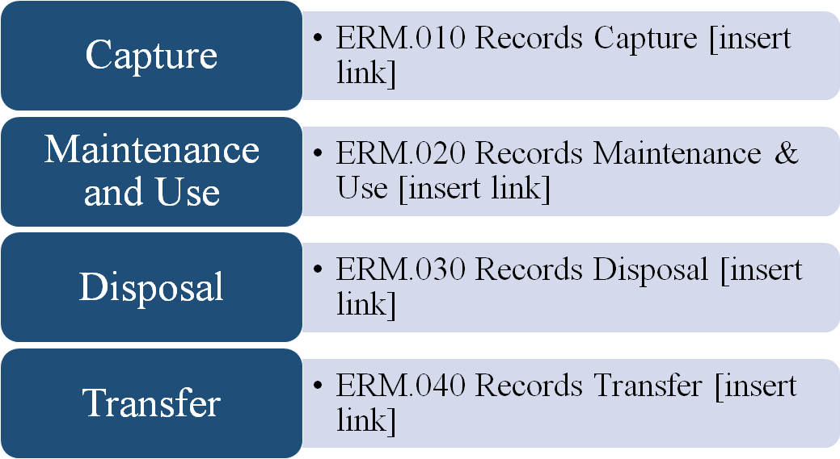

Figure 2. Records Lifecycle Function

Within each of the Functions, we identified the Activities that occur in that Function (see Figure 3). For example, in the area of Capture are Records Creation, Records Validation, and Records Retention. For each Activity, we identified the Capabilities needed to accomplish that Activity. For each Capability, we identified the Inputs, Outputs, and Processes needed to accomplish that capability. For each Process, we identified events needed to accomplish that Process. The Capabilities can be manually executed or automated, and are solution agnostic.

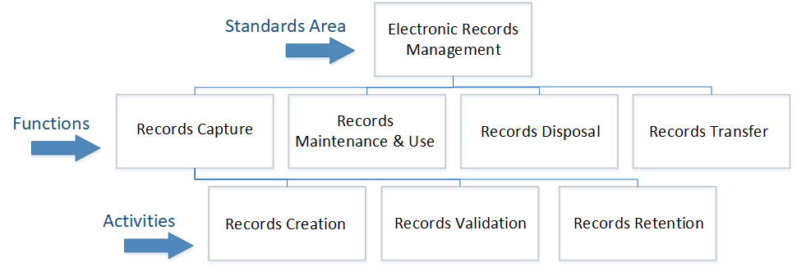

Figure 3: Examples of Service Area, Functions, and Activities

A complete listing of the ERM service area functions and activities is found in the ERM Business Lifecycle and Business Capabilities document. The Electronic Records Management capabilities should be integrated into all mission support functions that create records.

The business scenarios show the ideal flow of events. Due to agency-specific situations and processes, agencies will have to take steps not covered in the use cases to manage their electronic records. There may be additional starts and stops to the processes not shown in the use cases.

By building business scenarios documenting the key activities, inputs, outputs, and the intersections with other mission support functions, NARA hopes to better describe to vendors and service providers the Federal requirements for managing electronic records.

The Use Cases are written from the perspective of a Federal agency and show how records move through the lifecycle. Each use case contains a synopsis and assumptions that imply dependencies among the use cases. Based on these dependencies, use cases can be organized into a use case workflow reflecting the lifecycle of records. ERM use cases begin with creation and capture of records and end with disposal or transfer of records to NARA. The Business Actors are the individuals involved in each Business Scenario that make up the Use Cases. The Assumptions are the conditions that exist or conditions that have been executed prior to the start of the Use Cases. An Event is a building block that forms a Business Scenario; the Input(s) is the item or group of items needed to execute an Event; the Output(s) is the result of the Event being executed and is something that is needed to proceed to the next Event in the Business Scenario.

Each Use Case is assigned an identifier that tells information about the use case. The Use Case identifier includes information about the key underlying components. The notation for a use case identifier is shown in Figure 4:

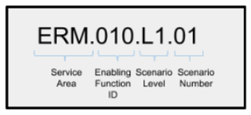
Figure 4: Use Case Identifier Notation

Each section also includes visual workflows which display how the flow of events can occur in each business scenario. As previously stated, these workflows show the ideal business scenarios. Agencies may have starts and stops in the process that need to be addressed and are not shown in the visual workflow. The events that comprise each business scenario do not necessarily flow in sequential order.

Additionally, the workflows will be influenced by the solutions and services model selected and deployed by the agency. Whether the agency uses a traditional ERMS, embedded records management, or ERMaaS microservices, the workflows will need to be altered to fit different approaches.

Business Scenarios
Business Scenarios identify the events that occur when executing a Process. Each Business Scenario reflects the scope and complexity of the Process across the Federal Government. Business Scenarios are categorized as follows:
- Level 1 (L1): Affects most Federal agencies and/or impacts a large transaction volume or dollar value within the Federal government
- Level 2 (L2): Affects multiple Federal agencies and requires some specialized processing from the service consumer or auditor perspective
- Level 3 (L3): Affects a few Federal agencies and requires unique processing, but is mandated by legislation

Appendix: Description of Key Terms
LIFECYCLE PHASE | DEFINITION
Capture | The process of placing an object under records management control for access and disposition purposes. Objects are not necessarily moved from the system they reside in when they are captured. Records can be imported from other sources, manually entered into the system, or linked to other systems.
Maintenance & Use | The process of managing records through their most active stage. This includes ensuring records are migrated and transformed as systems change, so the records remain usable. Digital preservation is particularly important for permanent records that will eventually be transferred to NARA.
Disposal | The process of disposing of records scheduled for destruction. Records that meet these conditions are destroyed in accordance with their records retention schedule according to 36 CFR 1226.24 and methods such as those outlined in NIST Special Publication 800-88. Electronic records scheduled for destruction must be disposed of in a manner that ensures protection of any sensitive, proprietary, or national security information.
Transfer | The process of transferring records that have been scheduled as permanent to the National Archives of the United States. This includes records that have been scheduled as permanent, records that are designated as permanent in a GRS; and, when appropriate, records that are accretions to holdings (continuations of series already accessioned.)
ACTORS | DEFINITION
Agency Personnel | Refers to Federal employees, contractors, volunteers and others that create, receive, access or use federal records on behalf of the agency.
Agency Records Management Staff | Refers to the designated Agency Records Officer and other records management staff involved with administering the records management program.
Business Process Owner | Refers to the authorized person(s) in charge of a business process that creates and maintains records.
Information System Owner | Refers to the person(s) responsible for the overall procurement, development, integration, modification, operation, maintenance, and retirement of an information system.
NARA Accessioning Archivists | Refers to the accessioning archivists who work with agencies to transfer permanent electronic records to NARA.
NARA Appraisal Archivists | Refers to the appraisal archivists in the Office of the Chief Records Officer who work with agencies on scheduling and appraising records.
KEY TERMS | DEFINITION
Accessioning | Refers to the process of transferring physical and legal custody of permanent records from federal agencies to the National Archives and Records Administration (NARA).
Agency Records Management System | Refers to the systems or services the agency has designated to manage its electronic records.
Assumptions | Refers to a condition that exists or a condition that has been executed prior to the start of the use case.
Capstone Official | Refers to senior officials designated by account level or by email addresses, whether the addresses are based on an individual’s name, title, a group, or a specific program function. See NARA Bulletin 2013-02: Guidance on a New Approach to Managing Email Records.
Group of records | Refers to a collection of like records that are scheduled and maintained together. For example, a case file or records relating to a specific project that can all be analyzed and assigned a disposition together. Often known as records series. Not to be confused with NARA's designation of Records Groups for each agency.
Input | Refers to an item needed to execute an event that is part of a business scenario.
Metadata | Metadata are elements of information that answer the questions ‘who, what, where, when, and why’ regarding electronic records. Metadata elements provide administrative, descriptive, and technical information that describe the structure and content of electronic records. Metadata elements also provide contextual information that explains how electronic records were created, used, managed, and maintained prior to their transfer to NARA, and how they are related to other records. This information enables NARA to appropriately manage, preserve, and provide access to electronic records for as long as they are needed. Examples include identifier, creator, title, creation date, rights, etc.
Output | Refers to the result of an event being executed as part of a business scenario. An output is needed to proceed to the next event in the business scenario.
Process | Refers to a series of events or steps taken in order to execute a business scenario.
Reporting | Generating reports to allow for further analysis and to demonstrate effective controls and compliance. Reports may include search results, records eligible for disposition, audit logs, and other customized or ad hoc reports.
RECORD TYPE | DEFINITION
Office Management Applications | Office Management Applications refers to documents created with desktop and cloud applications, such as Microsoft Office, Adobe, or other Office Management software. These documents include word processing documents and presentation formats.
Electronic Messages | Electronic Messages refers to email messages, instant messages, chat messages, text messages, and voicemail messages that meet the definition of Federal records.
Social Media | Social Media refers to messages generated through a social media application that meet the definition of Federal records. Examples of social media applications include Facebook, Twitter, Slack, Pinterest, Google Plus, and Skype, among others.
Cloud Services | Cloud Services refers to technology that allows users to access and use shared data and computing services via the Internet or a Virtual Private Network. It gives users access to resources without having to build infrastructure to support these resources within their own environments or networks. Federal records can reside in a cloud environment hosted by a 3rd party service provider.
Websites | Websites refers to (1) web content records, which represent information presented on a website, and (2) website administrative records, which provide evidence of the management and operations of the website. Examples of website records include the following: web page content, dynamic content, scripts, list of URLs referenced by hyperlinks, website design records, etc.
Digital Media (Photo) | Digital Media (Photo) include still photographs of natural, real-world scenes or subjects produced by digital cameras, and scanned images of photographic prints, slides, and negatives that meet the definition of Federal records. These records must also be in the correct file formats according to NARA's transfer guidance.
Digital Media (Audio) | Digital Media (Audio) encompass formats used to encode recorded sound as machine readable files by converting acoustic sound waves into digital signals that meet the definition of Federal records. Digital audio formats are generally composed of both a wrapper format, usually the common name associated with the file extension, and an encoding method or codec. These records must also be in the correct file formats according to NARA's transfer guidance.
Digital Media (Video) | Digital Media (Video) refers to digital moving images consist of bitmap digital images or “frames” displayed in rapid succession at a constant rate, giving the appearance of movement. Includes both video digitized from analogue sources and born digital video) that meet the definition of Federal records. These records must also be in the correct file formats according to NARA's transfer guidance.
Structured Data | Structured data refers to data that is stored in defined fields. Categories for structured data include database formats, spreadsheets, statistical data that is the result of quantitative research and analysis, and scientific data collected by instrumentation tools during the scientific process.
Engineering Drawings | Engineering Drawings refer to technical drawings used to convey all the required information to allow a manufacturer to produce that component. Engineering drawings include computer aided design (CAD) formats, vector graphics files that rely on mathematical expressions to create multi-dimensional computer graphics intended for use in engineering and manufacturing design. CAD programs can generate representations and animations of two and three-dimensional surface projections of objects. Engineering Drawing records must meet the definition of a Federal record, and must be in the correct file formats according to NARA's transfer guidance.
Shared Drives | Shared Drives, also known as network drives, refer to managed shared servers which provide electronic storage space for authorized users to house Federal records in supported file formats. Shared Drives can be manage on premises or in the cloud. Examples include SharePoint, OneDrive, and Google Drive. The use of shared drives poses recordkeeping challenges because agencies may store content that includes Federal records and non-record materials.
VISUAL WORKFLOW KEY
Rectangle  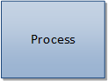 | Process or activity
Diamond  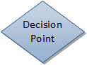 | Decision point, usually indicated by yes/no text
Arrows | Flow of activity
Oval  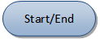 | Start or end of a process

