November 10, 2014

[Insert POC]
[Insert Inside Address]

Dear [Insert POC]:

The Federal Records Centers Program (FRCP) maintains physical control of nearly 4 million cubic feet of records at the Washington National Records Center (WNRC). At the present time, the center is effectively full; available storage space for unclassified records is insufficient to accommodate the volume of new materials anticipated. We are now considering space as a single entity across our entire portfolio of 24 buildings clustered into 18 FRCs. System wide, we are at 93% capacity. In order to use the available space most effectively as directed by OMB memo M-12-12, Section 3, we will be implementing diversions from FRCs that are full, to FRCs with space available.

The WNRC to Philadelphia diversion served as a successful pilot and it is necessary for us to expand now that Philadelphia is reaching capacity.

Beginning with SF135s approved on November 24, 2014, we will begin diverting all temporary, unclassified records that are approved from that date forward to the Atlanta Federal Records Center (FRC) instead of the Philadelphia FRC.

We are committed to reducing or eliminating the impact of this new policy on our customers. You may continue to submit your SF 135s to WNRC for approval. Each office submitting an SF 135 will receive communication at the time of approval with instructions that detail how to ship the records directly to Atlanta. Additionally, there is no change when requesting your records through ARCIS.

Based on this, we anticipate a two day transit time on records shipping from Atlanta. We recommend that you plan your request for records accordingly to meet your business need.

Please note that this diversion only involves temporary, unclassified records. WNRC will continue to store all classified materials maintained within the FRCP system, as well as any permanent or unscheduled holdings that would have previously been delivered to the center.

FRCP staff members continue to work diligently to provide high-quality, cost-effective records storage for our customers, and we appreciate your partnership with us as we build on our shared commitment to preserving Federal records. We would be happy to meet with you to discuss any concerns or questions you may have about the records diversion or other FRCP services.

Please feel free to contact your account representative [Insert Account Manager Name] at [Insert Account Manager Phone Number]

Sincerely,
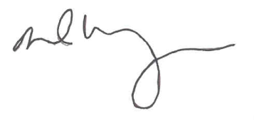
DAVID M. WEINBERG
Director, Federal Records Centers Program

