May 1, 2017

To Our Valued Customer:

To prepare for our semi-annual Information Technology maintenance service, our Internet service will be limited between Friday, May 5, 2017 at 9:00 p.m. through Monday, May 8, 2017 at 6:00 a.m. During this maintenance window, agencies will be unable to access ARCIS and the ARCIS Customer Portal.

We apologize for any inconvenience this may cause your agency.

We appreciate your continued support of NARA’s Federal Records Centers Program, and we look forward to continuing our relationship as we build on our shared commitment to Federal records management.

Sincerely,

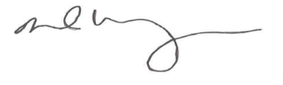

DAVID M. WEINBERG

Director, Federal Records Centers Program

